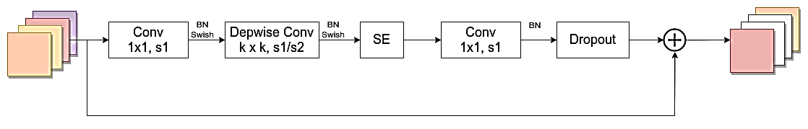
Figure 3.2 Structural diagram of the MBConv module
Note. Reprinted from EfficientNet: Rethinking model scaling for convolutional neural networks, by M. Tan and V. Q. Le (2019), CoRR, abs/1905.11946 . DOI: 10.1016/j.compag.2024.109001

